1. اقرأوا القصّة.

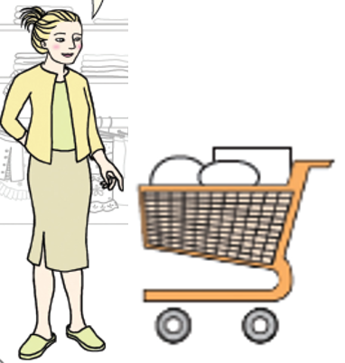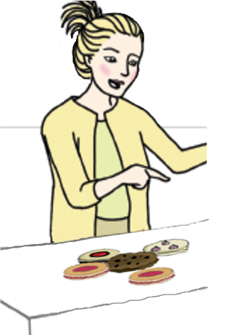

This is Sally.

Sally is very busy.

On Sundays Sally shops for food.

On Mondays she swims in the sea.

On Tuesdays she buys bones for the dog.

On Wednesdays she bakes sweet cookies.

On Thursdays she plants flowers in the garden.

On Fridays she cooks dinner.

On Saturdays Sally is very tired so she sleeps all day.

1. اكتبوا ما الذي تفعله سالي كلّ يومٍ بحسب القصّة.

|  |  |  |  |  |
| --- | --- | --- | --- | --- |
| **Sunday** | **Monday** | **Tuesday** | **Wednesday** | **Thursday** |
| Sally shops for food. |  |  |  |  |

9. أجيبوا عن الأسئلة بحسب القصّة.

1. When does Sally cook dinner?  
   Sally cooks dinner on ________________________ .
2. Why does Sally sleep all day on Saturday?

* because she is sad
* because she is tired
* because she is hungry
* because she is happy