Alkadisya elementary school

Name:___________

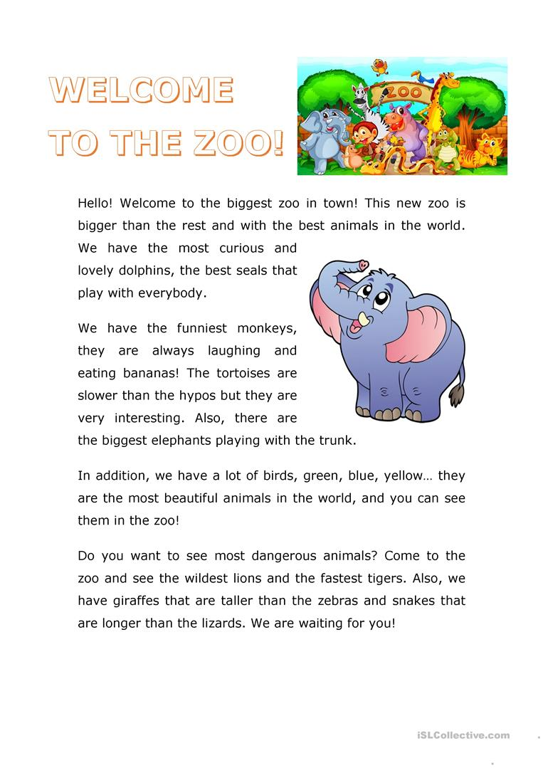

Read the text, then answer the questions:

1-where is the biggest zoo?

2- What can the seals do?

اكمل الجمل: 3- complete the sentences:

A- The tortoises are _______ that the _______

B- We have the funniest _______, they are always_______ and eating _______.

4- Find in the text five names of animals:

جد في النص خمسة اسماء حيوانات:

**1-_______ 2-_______ 3-________ 4-________ 5-_________**

5- Draw your favorite animal, then write a sentence about it:

ارسم حيوانك المفضل, ثم اكتب جملة توصفه:

|  |  |
| --- | --- |
| meaning | word |
| مدينة | town |
| فضولي | curious |
| الاطرف | the funniest |
| يضحك | laughing |
| السلاحف | tortoises |
| ابطأ من | slower than |
| فرس النهر | hypos |
| خرطوم | trunk |
| بالاظافه | in addition |
| خطير | dangerous |
| الاسد الأعنف | wildest lion |
| السحالي | lizards |