- اكتبوا الكلمة الملائمة تحت كلّ صورة.
استعينوا بمخزن الكلمات.

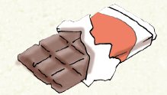 | 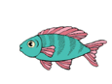 | 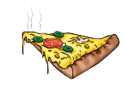 | 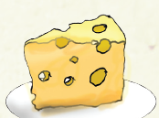 | 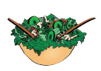
_______ | ________ | _______ | _______ | _______
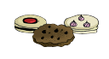 | 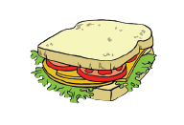 | 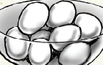 | 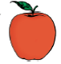 | 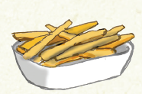
________ | _________ | _______ | _______ | _______

chocolate | cookies | eggs | salad | apple
fish | pizza | sandwich | cheese | chips

- مدّوا خطًّا بين الجُمَل والصّور.

My father is eating chicken. |  | 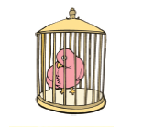
The baby is drinking milk. |  | 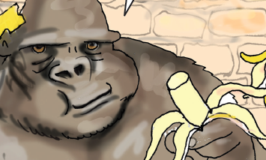
The bird is in the cage. |  | 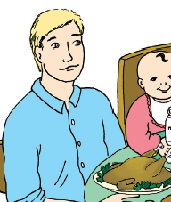
The girl is sleeping. |  | 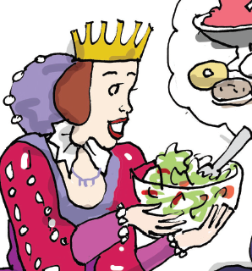
The gorilla is eating a banana. |  | 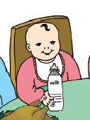
The queen loves salad. |  | 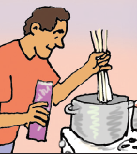
The man is making pasta. |  | 